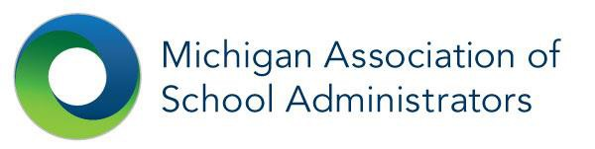
School ADvance Training and Workshop Facilitation
Event Registration

Date of Event: Location of Event:
Attendee Information

First Name: | Address:
Last Name: | City, State, Zip:
District/Co: | Phone:
Position: | Email:

Please register me for:

Basic Training 2 Day $325/participant
New Administrator Training 1 Day $225/participant
School ADvance Refresher 1 Day $3600/session up to 15 participants

Board Training Part 1 and Part 2 $350/participant
Board Evaluation Facilitation 1 Day $2500/session up to 5 participants

Grand Total: _________________________________________________________________________________________Payment

Check payment to: MASA 1001 Centennial Way, Suite 300, Lansing, MI 48917
Credit Card Payment:
Card Number:______________________________________ Expiration Date:__________________
Name of Card: ______________________________________ SIC (back of card):-------------------------

Signature of Cardholder Date

To complete your registration: Print and fax the completed from to (517) 327-0779, or save and email to gomasa@gomasa.org.
No refunds two weeks prior to the event. A $25 late fee will be assessed if not paid in full by date of event and also for cancellations.

